We are trying to find a path from S to G in the following graph:
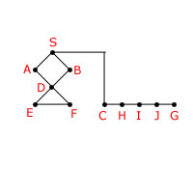
Connections (all undirected):
S: A B C F: D E
A: S D G: J
B: S D H: C I
C: S H I: H J
D: A B E F J: I G
E: D F
The heuristic distance estimates to the goal are:
S = 10, A = 5, B = 8, C = 6, D = 7, E = 6,
F = 5, H = 3, I = 2, J = 1, G = 0
Examine states in alphabetical order when no other order is specified. In particular, assume that the list of descendant states of a parent state are placed on Q so that they are examined in alphabetical order. So, this determines the order that both depth first and breadth first explore the space. Also, if you have ties in heuristic searching, use alphabetical order to break ties.
Write the sequence of states expanded by the specified search methods in our implementation. In each answer slot, enter a state name, including S and G. States may be repeated in the sequence. You will save yourself a LOT of confusion if you first convert the graph above into the appropriate search tree.
- Depth-First (using Visited List)

- Depth-First (NOT using Visited List)
- Breadth-First (using Visited List)
- Breadth-First (NOT using Visited List)
- Best-First (using Visited List)

